Office use only

- Autism - Date received:
- EYIS - Date received:
- SENSORY - Date received:
- STEPS - Date received:
DATE STAMP HERE FOR RECIEPT IN
SEND OUTREACH SERVICES
SEND Outreach Services
Discovery School
Battery Road,
West Thamesmead
London SE28 0JN

Telephone number 020 8921 3311

Please note: All referrals require pages 1-5 to be completed and then the additional supplementary form for the individual service/s required.

Incomplete forms will be returned to the sender.

Please indicate the service(s) you would like the child/young person to be referred to:
Autism Outreach Early Years Inclusion Service
Autism-Outreach@royalgreenwich.gov.uk EYIT@royalgreenwich.gov.uk
(Complete front section and appendix 1) (Complete front section and appendix 2)

Sensory Service STEPS
Sensory-Service@royalgreenwich.gov.uk STEPS@royalgreenwich.gov.uk
(Complete front section and appendix 3) (Complete front section and appendix 4)

Please note additional essential reports/evidence required for individual service referral

Child’s details (BLOCK CAPITALS)
Surname: |  |  | First name/s: |  |  |  | DOB:
 |  |  |  |  |  |  | Age: ….…years ….…months
Male/Female: |  |  | Parent/Carer names:
Home: |  |  |  |  Mobile:
Who has parental responsibility for the child?  As above Other  (If other, please provide details) |  |  |  | Name of School/Early Years Setting:
Languages spoken at home  Main Language:  Others: |  |  |  |  |  |  | Interpreter essential:  Yes / No
Home address:  Postcode: | All correspondence will be sent to this address unless otherwise indicated.
 Email:
MONITORING SECTION

The information requested below will be used to help develop appropriate pupil support and to ensure the development of the service for students from particular ethnic minority groups.
Ethnic background does not refer to the country of birth or nationality of the pupil, but to his/her predominant racial and cultural family background.
Parents/guardians should indicate their choice of answer.
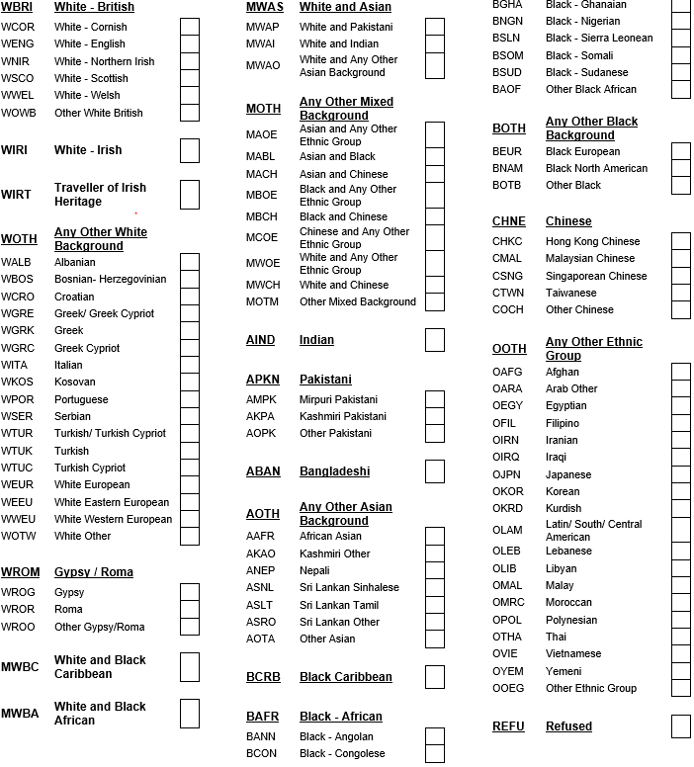
Address of School/Early Years setting:

Telephone number:
Pattern of attendance: |  | (please circle)  Days: M T W T F |  |  | Attendance percentage:  % |  |  |  | Sessions: if attending part time  AM/ PM
Name of planned School/Setting if about to transfer:

Name of SENCo: |  |  |  |  |  | Year group:  (please circle) |  | Nursery (FS1)  Reception (FS2)  1 2 3 4 5 6 7 8 9 10 11 12 13  Post 16
Name of Class teacher:

Name of LSA/1:1 support worker:

If you know where your child is on the Code of Practice please indicate below. Please or

Is your child at SEN Support? | Does your child have an Education Health Care Plan (EHCP)?  If so, what banding is allocated to the EHCP:
Is your child a Child in our Care (previously known as Looked After Child)? | Has your child ever been subject to a Child Protection Plan (CPP)?

Please indicate below which of these services are, or have been, involved with this child and attach any relevant reports
Speech & Language  Therapy | Occupational  Therapy | Educational  Psychology
Community  Paediatrician | Physiotherapy | Social Care
Dietetics | Music Therapy | Health Visitor/  School Nurse
Early Years (0-3)  Keyworker | Audiology | Autistic Spectrum Disorder  Outreach Service
Early Years Inclusion  Service | Sensory Service | Support Team for  Education in Primary  School (STEPS)
Other (please specify): | (If appropriate) NHS number:  Name of hospital:  Consultant details:

Please complete for each agency currently working with the child/young person/family. (continue on separate sheet if necessary)
Name of Service Provider | Contact Details | Length/ Date of Treatment | Additional Information/ Report Enclosed?

Referrer details
Signature of referrer: | Date:
Print name: | Role (please indicate here if parent is making the referral):
Contact address (not necessary if parent): | Contact no:

Parent/carer consent
(Requests cannot be accepted without the consent of the parent/guardian.)
All SEND Outreach Support Services are consent-based services.
Until we have signed consent from someone we reasonably believe has legal parental responsibility for a child, we will not action a referral, although it will be logged.

Consent
I confirm that I have parental responsibility for the child named above.
I agree to my child being seen/assessed by relevant professionals if necessary.
I agree that report(s) written by professionals can be forwarded to Royal Borough of Greenwich Children Services and shared with other relevant professionals without further consent.

Photographs
The Outreach Services may take photographs of your child during their assessment, to illustrate particular technicalities or interventions. These pictures will not be used for other purposes.
Please tick the box to confirm that you are happy for this to happen.

Information sharing and storage
Everyone working for Royal Greenwich Children’s Services has a legal duty to keep information about you and your child confidential. So that we can all work together for your child’s benefit we may need to share some information with, or seek information from other professionals working with your child.

In line with safeguarding regulations, we may share information without consent if we believe a child is at significant risk of harm if information is not shared.

In addition to paper-based files, information may also be collected and stored on Royal Greenwich Council Children’s Services databases – this information may be shared within the Royal Borough of Greenwich.
Our Privacy Notice Children's Services | Royal Borough of Greenwich (royalgreenwich.gov.uk) gives more details on how we manage and retain information.

Signature of parent/carer:  Relationship to child: | Print name:  Date:

Appendix 1 – Autism Outreach Service

SUPPLEMENTARY INFORMATION FROM PARENTS (to be completed by the family)
We would really like to have some additional information about your child to understand them better before we see them. If you are able to fill this in we would find it very useful. Alternatively, we would be happy to ring you and complete this by telephone. If you would like us to do this, please contact Admin Team on 020 8921 3311 and we will arrange for someone to ring at a convenient time for you.

Autism Diagnosis made by:
Name:
Position:
Clinic:
Date:

Please return this form asap even if some sections are not completed or relevant to your child.

What does your child like doing at home? What are their strengths and interests?

How does your child feel about school?
(What are they like going into school in the morning? Do they enjoy completing homework?)

How does your child communicate/interact with others?
(e.g. Take your hand, pointing, words, phrases, full sentences? Do they play with other children or do they prefer their own company?)

How independent is your child in areas such as toileting, eating and diet, sleeping, dressing, getting ready for things etc?

Do you have concerns about your child’s behaviour at home, and any triggers you are aware of that make your child unhappy/distressed?

Does your child have particular sensory needs? (Such as being sensitive to noise, touch, taste, repetitive behaviour or movements, sensitive to specific environments, etc.)

Does your child know about their diagnosis? Have you had a conversation with your child regarding their diagnosis?

What do you see as the main priorities for your child’s development?

Anything else you want us to know? (How does the school let you know how your child is doing in school? Are there any particular problems in school that you are aware of?)

ABBREVIATIONS/ GLOSSARY OF TERMS

Autism Outreach Service | Support families with a child with an Autism.  The Autism Outreach Service supports both mainstream schools and families to  make sure that they are able to meet the needs of children with autism.
Audiology | Audiology is a branch of science that studies hearing, balance, and related disorders. Its practitioners, who treat those with hearing loss and proactively prevent related damage, are audiologists.
CP | Community Paediatrician. Community Paediatricians are children’s doctors who specialise in childhood behavioural disorders, childhood disability and complex care.
CPP | Child Protection Plan. Children at risk may be made the subject of a child protection plan. A child protection plan is drawn up at a child protection conference. The plan is a written record for parents, carers and professionals.
Dyslexia | Dyslexia is a common learning difficulty that can cause problems with reading, writing and spelling. It's a "specific learning difficulty", which means it causes problems with certain abilities used for learning, such as reading and writing. Unlike a learning disability, intelligence isn't affected.
EAL | English as an Additional Language -English as a second or foreign language is the use of English by speakers with different native languages.
EHCP | Education, Health and Care Plan- this is the replacement for a ‘statement of special educational needs’.
EPS | Educational Psychology Service- Educational psychologists help children or young people who are experiencing problems that hinder their successful learning and participation in school and other activities.
EYFS | Early Years Foundation Stage- sets standards for the learning, development and care of children from birth to 5 years old. All schools and Ofsted-registered early years’ providers must follow the EYFS, including child-minders, preschools, nurseries and school reception classes.
EYIS | Early Years Inclusion Service support Private, Voluntary or Independent sector early years settings. Settings must be in receipt of the Free Entitlement to Early Learning (FEEL) and Together for Two’s (TF2’s) funding. The Team offer general advice, support and training around early identification and Special Education Needs and Disability (SEND) issues that arise in a setting.
FS1 | Nursery.
FS2 | Reception class.
GP | General Practitioner- deal with a whole range of health problems they usually work in practices as part of a team that includes nurses, healthcare assistants, practice managers, receptionists and other staff.
LAC | Looked After Child is a child who is looked after by a local authority if a court has granted a care order to place a child in care.
LSA/ TA | Learning Support Assistant/ Teaching Assistant - both job roles centre on providing support to teachers and pupils. They perform the same role working with all students, not only in SEND environments but also students in mainstream Primary and Secondary settings.
NHS | National Health Service is the publicly funded national healthcare system for England.
Ophthalmology | Ophthalmology is the branch of medicine that deals with the anatomy, physiology and diseases of the eyeball and orbit. An ophthalmologist is a specialist in medical and surgical eye disease.
OT | Occupational Therapy Service- Health care professionals who help a child/ young person achieve or maintain their maximum level of independence and develop practical life skills, so that they can participate to his/her full potential in the school environment.
Physio | Physiotherapy Service- Health care professionals who specialise in maximising human movement, function and potential.
PLP | Personal Learning Plan is developed for students—typically in collaboration with teachers, services working with the child, and parents—as a way to help them achieve short- and long-term learning goals.
SALT | Speech and Language Therapists provide treatment, support and care for children and adults who have difficulties with communication, or with eating, drinking and swallowing.
SEN/ SEND | Special Educational Needs and Disability the term 'special educational needs' has a legal definition, referring to children who have learning problems or disabilities that make it harder for them to learn than most children of the same age.
SENCo | Special Educational Needs Co-ordinator- has ‘an important role to play with the head teacher and governing body in determining the strategic development of SEN policy and provision and will be most effective if they are part of the school leadership team’.
SENSORY | Sensory Service provides support for children, aged 0-19 in homes and schools, who have semi-permanent or permanent deafness or vision impairment that cannot be corrected by glasses. Qualified teachers of the deaf/vision impaired can write advice and visit in schools/homes to support meeting each child’s individual needs, as well as offering deaf/vision awareness training and British Sign Language courses.
STEPS | Support Team for Education in Primary and Secondary supports children experiencing difficulties with reading, spelling, writing, maths and general learning. Depending on the need of the child, the support may take the form of group sessions, handwriting training, Personal Learning Plans tailored to a child’s individual needs and/or training school staff. STEPS can also assess children for dyslexia, provide specialist teaching for those with severe dyslexia and organise support for transitions.

